1. Write a program to read in two integers and perform the following operations on them: addition, subtraction, multiplication, division, and modulo.

**Addition:**

**Program:**

#include <iostream>

using namespace std;

int main()

{

int first_number, second_number, sum;

cout << "Enter two integers: ";

cin >> first_number >> second_number;

sum = first_number + second_number;

cout << first_number << " + " << second_number << " = " << sum;

return 0;

}

**Output:**

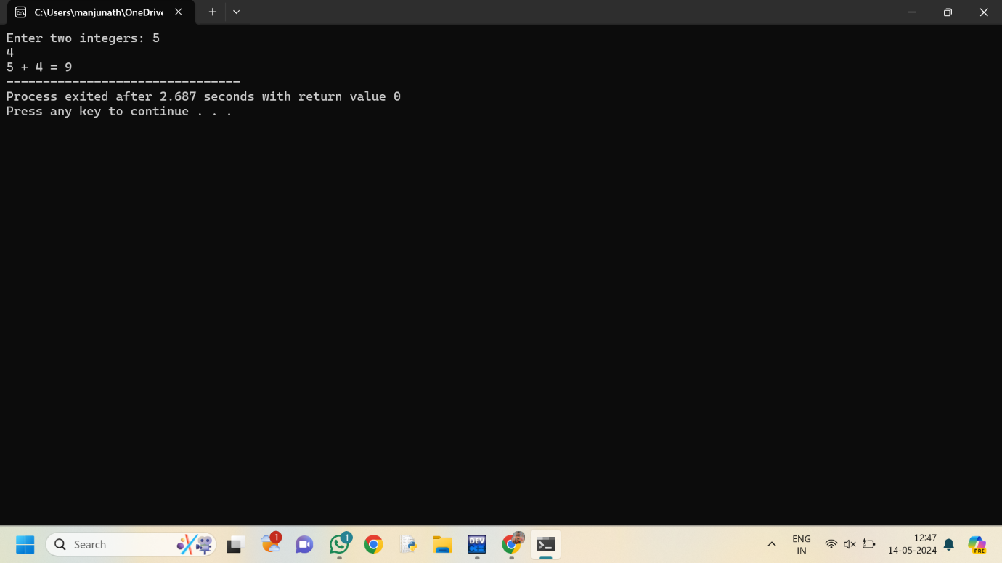

**Subtraction**

**Program:**

#include<iostream>

using namespace std;

int main()

{

int a=12;

int b=3;

int diff = a - b;

cout << diff;

return 0;

}

**Output:**

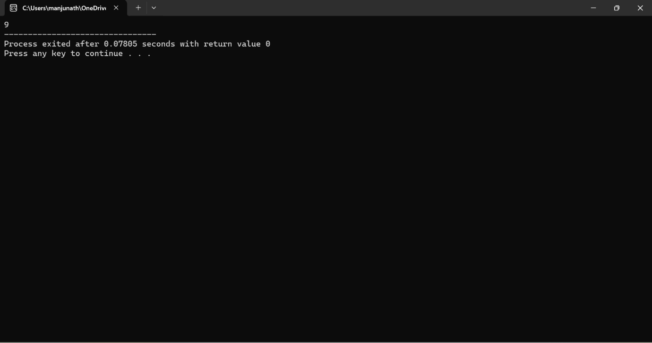

**3.MULTIPLICATION:**

**Program:**

#include<iostream>

using namespace std;

int main()

{

double num1,num2,product;

cout<<"Enter two numbers:";

cin>> num1 >> num2;

product=num1*num2;

cout<<"Product="<<product;

return 0;

}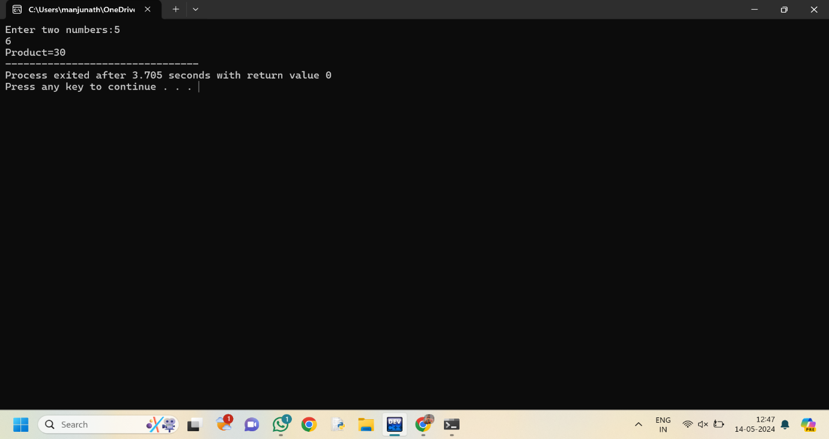

**4.DIVISION:**

#include<iostream>

using namespace std;

int main()

{

int a=12;

int b=3;

int div = a/b;

cout << div;

return 0;

}

**OUTPUT:  
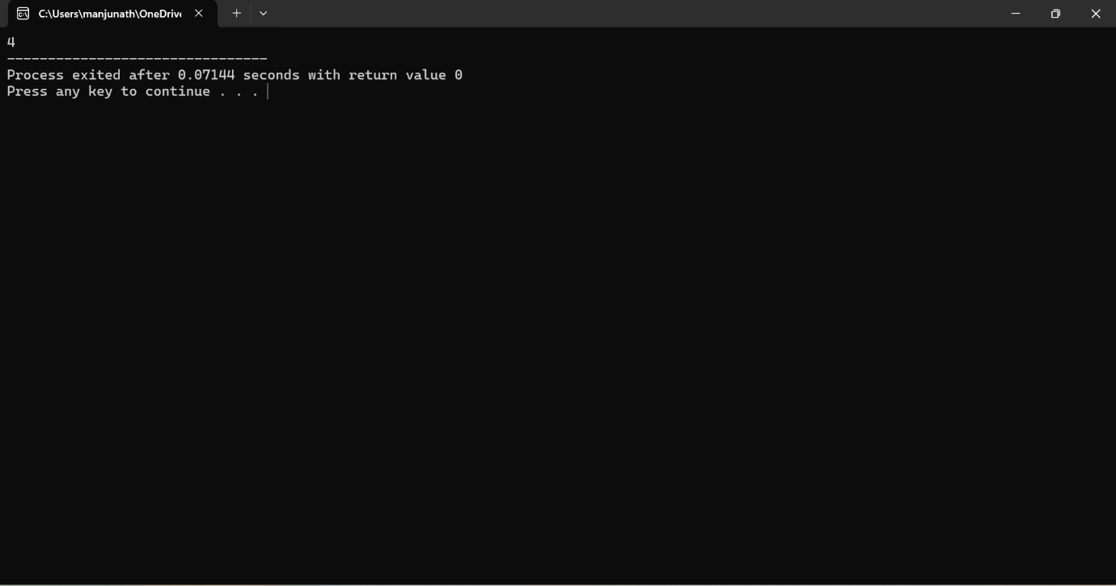**

**5.MODULE**

**Program**

**#include <iostream>**

**using namespace std;**

**int main() {**

**int a = 13;**

**int b = 5;**

**int modulo = a%b;**

**cout << modulo;**

**}**

**OUTPUT:**

